Mortality Trends Visualizations
Project Title: Time Series Analysis and Forecast of Drug-Induced Deaths in the U.S.
Nationwide deaths Plot:
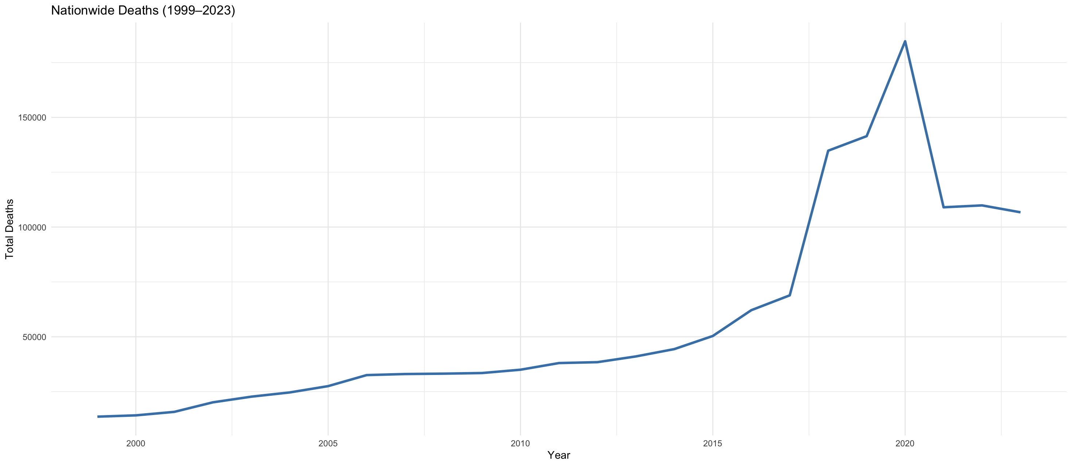

Gender Plot:
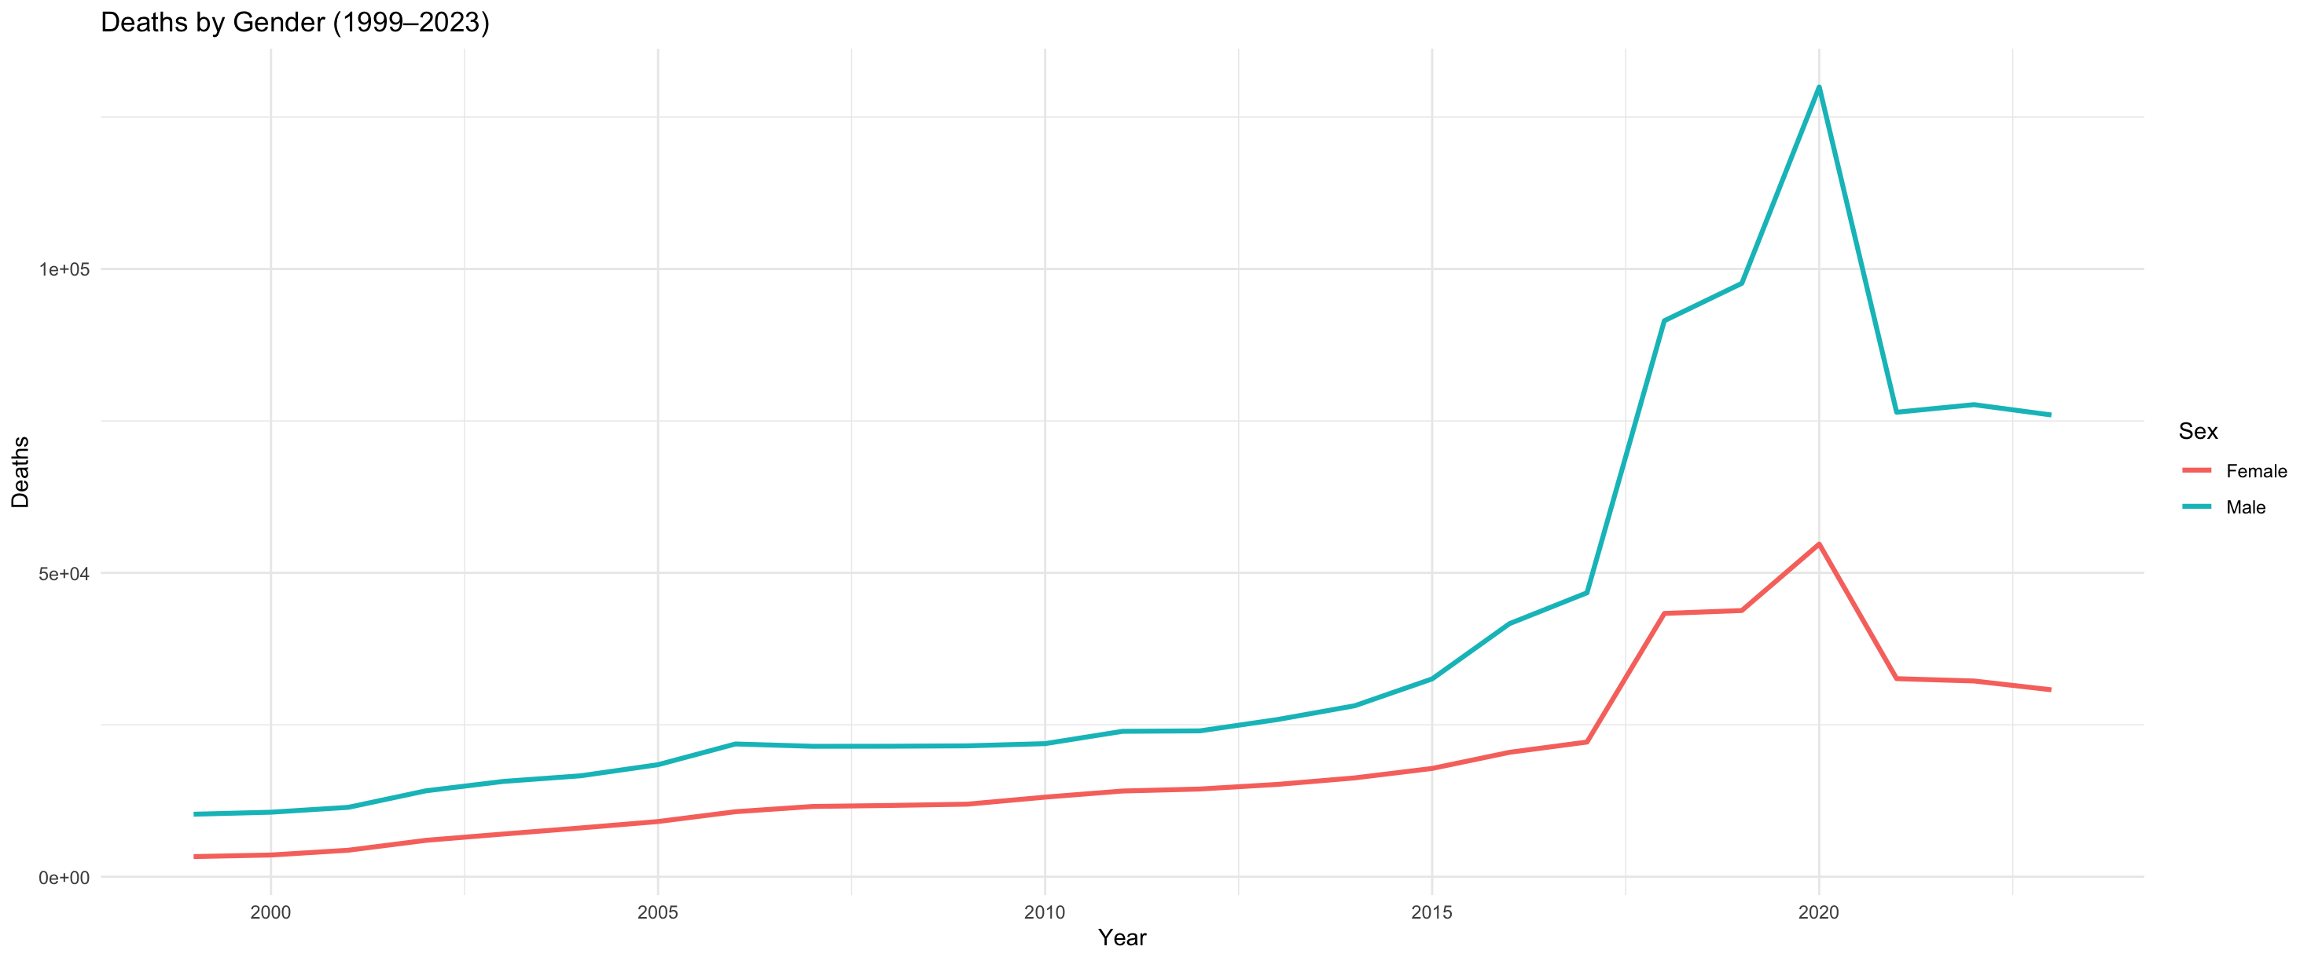

By States Plot:
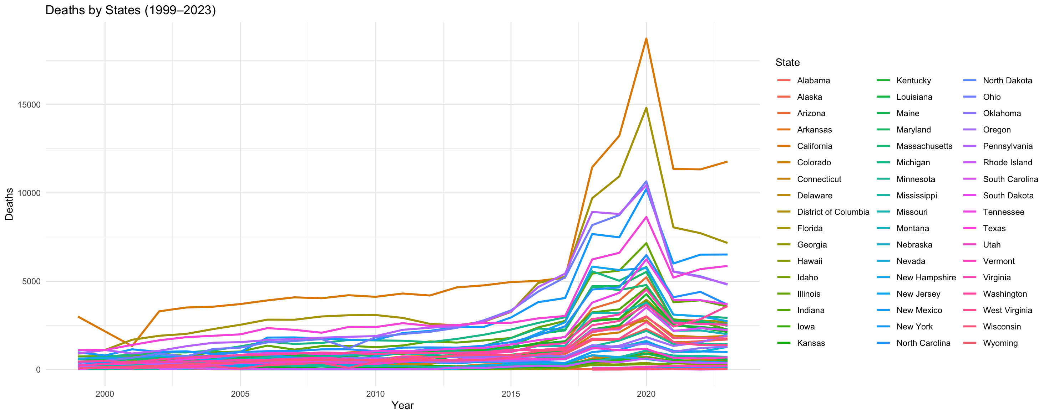

Top Five States Deaths Plot:
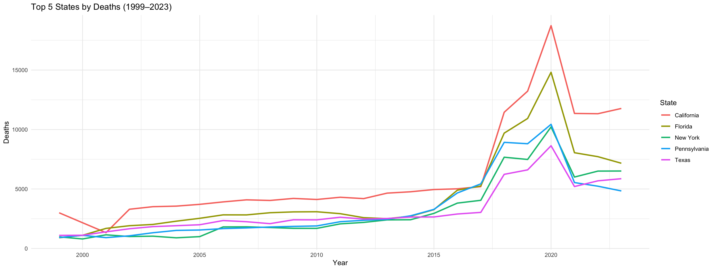

Top Five Five-Year Age Group Plot:
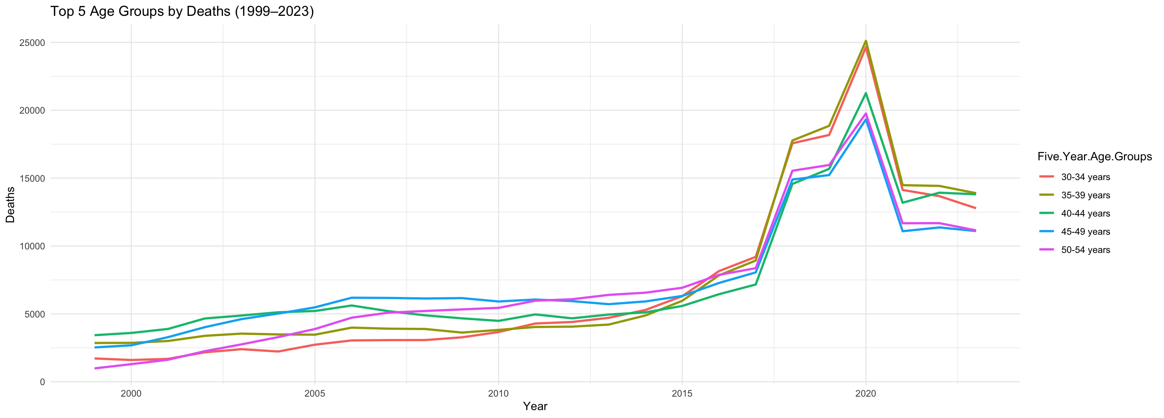

Nationwide Time Series Plot:
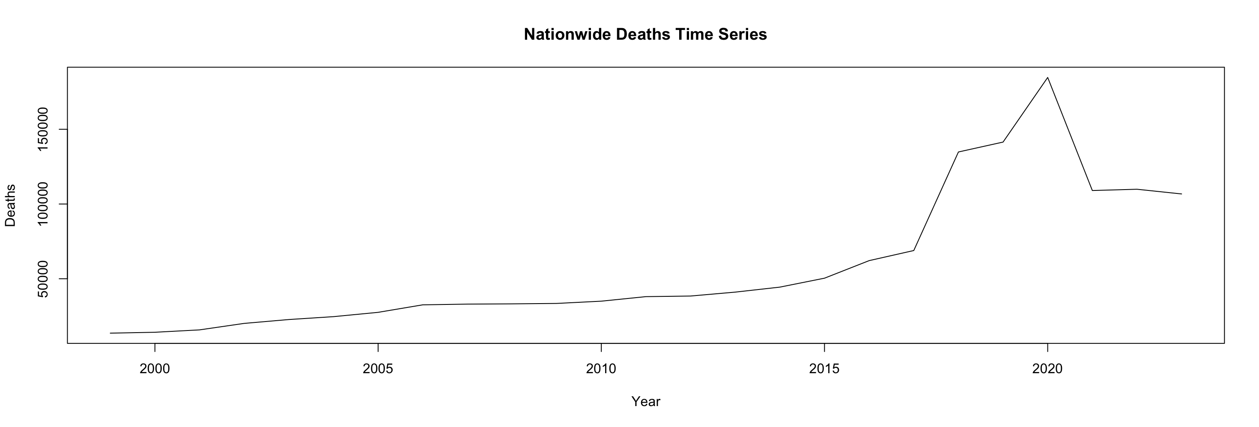

Check Stationarity:
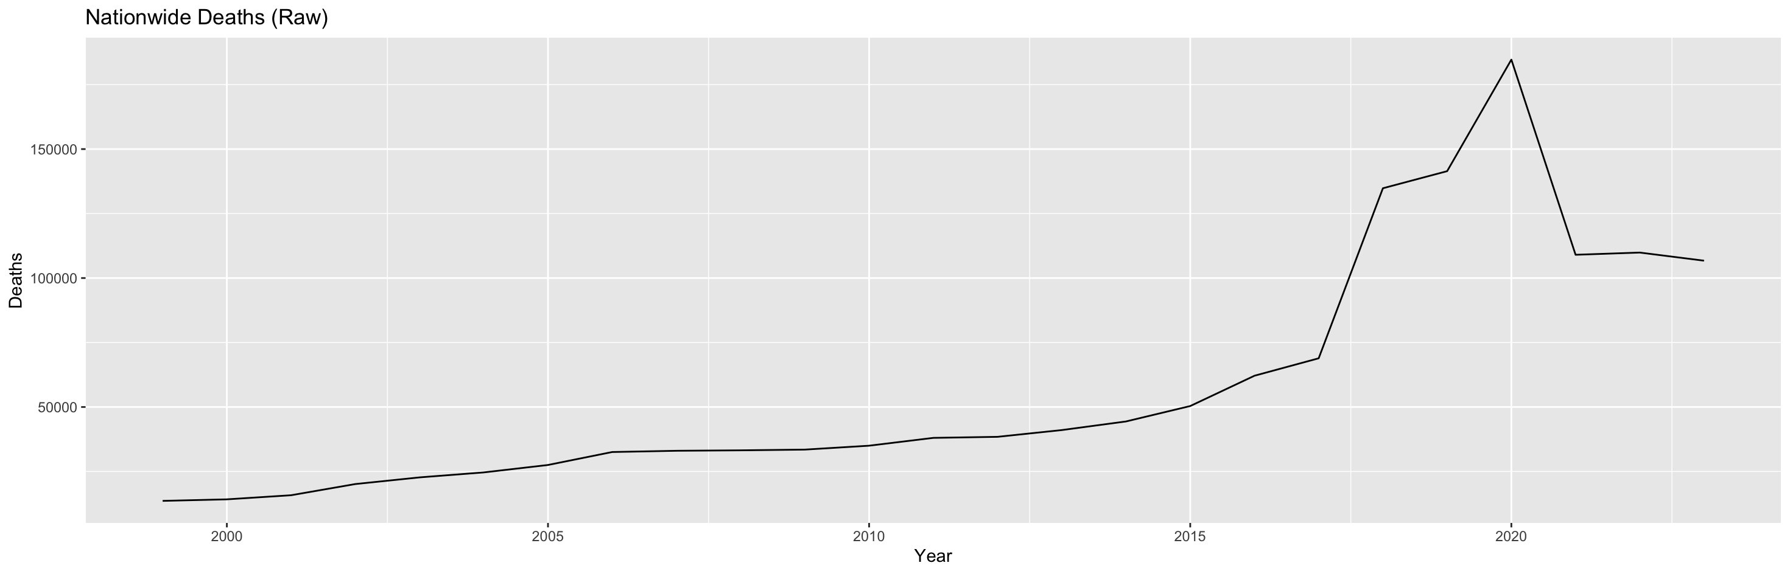

Plot for Differenced Data:
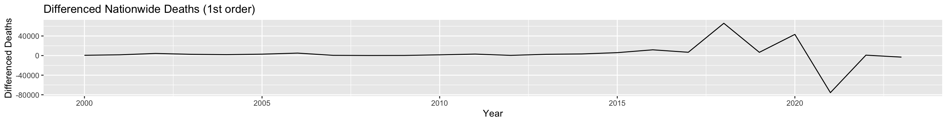

#ACF of Differenced Data
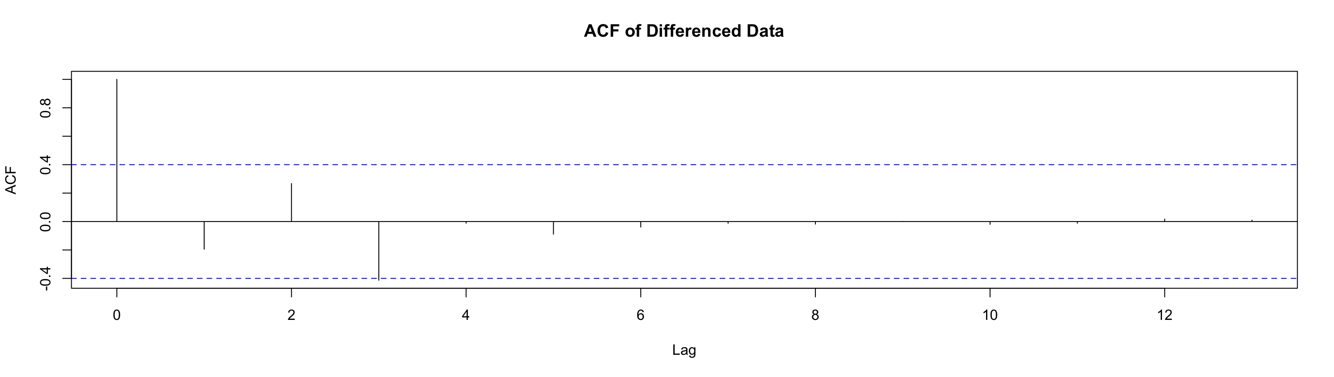

# PACF
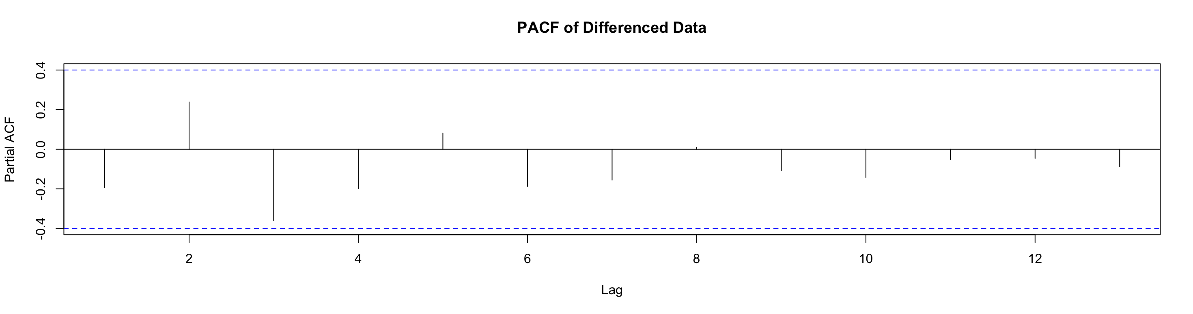

#Checking Residuals
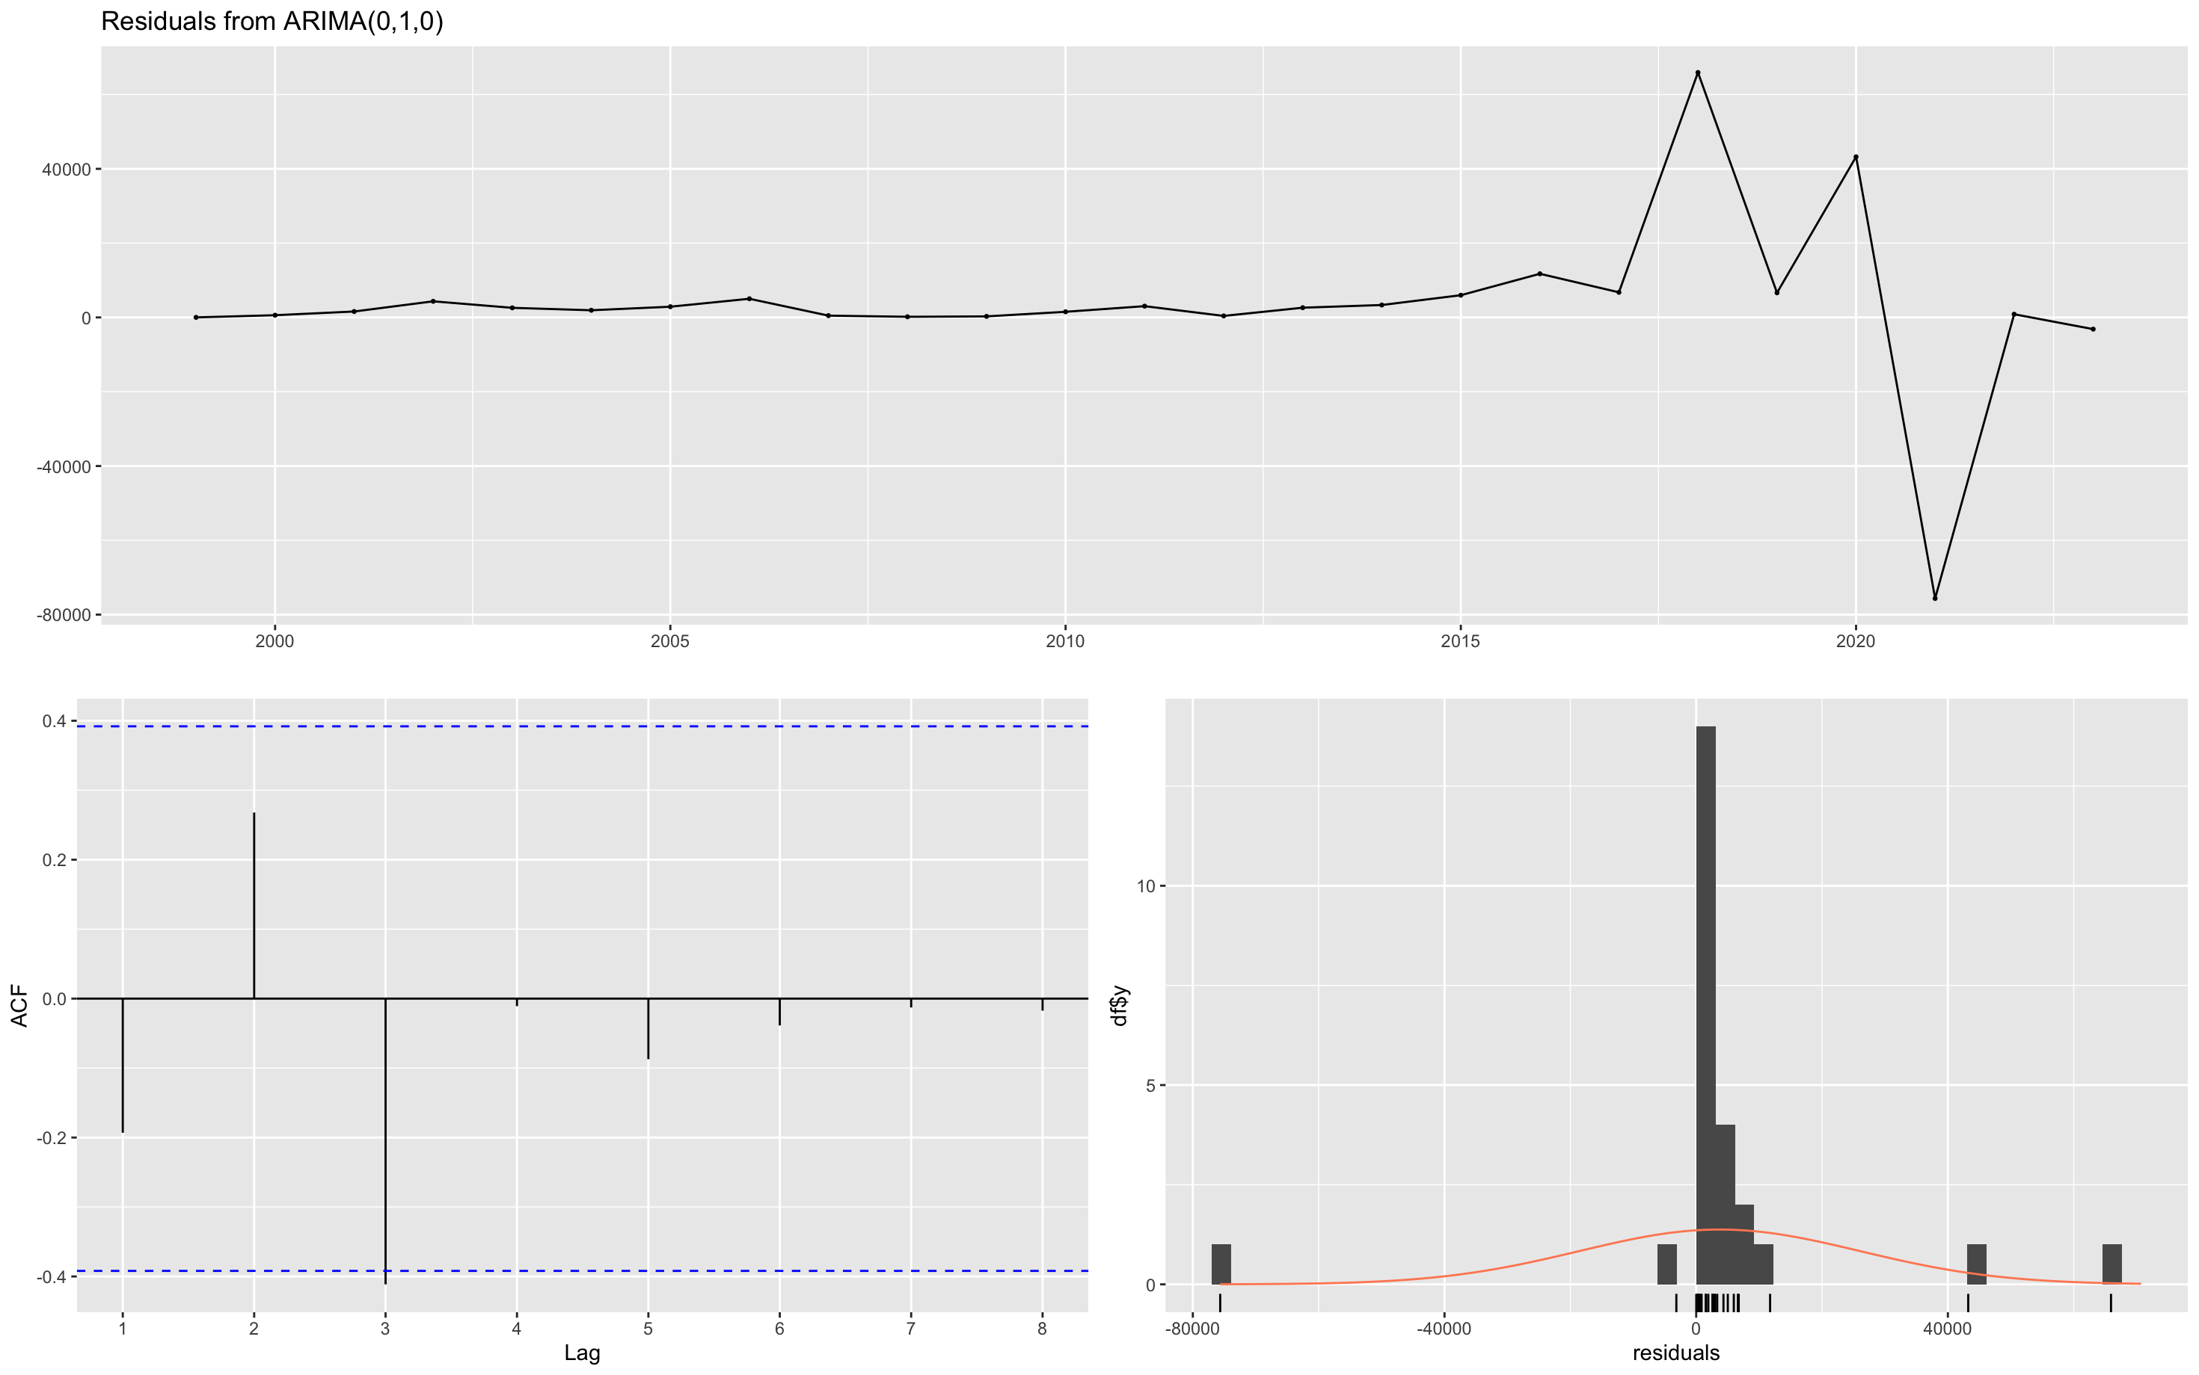

#FORECAST OF NATIONWIDE DEATHS
